**COMSATS University Islamabad,   
Abbottabad Campus**

**Project Proposal**

**for**

**Sentiment Analysis on Android/IOS Applications**Version 1.0

***By***

**Abdul Hameed Khan CIIT/FA18-BCS-002/ATD**

**Daud Ahmed CIIT/FA18-BCS-010/ATD**

***Supervisor*Ma’am Ayesha Jadoon**

***Bachelor of Science in Computer Science (2018-2022)***

**Table of Contents**

**1. Abstract……………………………………………………………………………………….3**

**2.** **Introduction 4**

**3.** **Problem Statement 5**

**4.** **Problem Solution for Proposed System 5**

**5.** **Advantages/Benefits of Proposed System 6**

**6.** **Scope 6**

**7.** **Interdependencies 6**

**8.** **Software Process Methodology 6**

**9.** **Tools and Technologies 8**

**10.** **Project Stakeholders and Roles 9**

**11.** **Data Gathering Approach 9**

**12.** **Conclusion 10**

**13.** **References 10**

**Abstract**

We all use different apps of play stores and app store and we give different opinions on different apps. There is a huge amount of reviews on every app. Now if the developer of an app wants to know about his app that whether the people have given positive reviews, negative reviews, and neutral on his app. There is no application for this problem on the Play Store and App store for giving us sentiment about our application; we have to manually check all the reviews. Therefore, it is very difficult for a human to do it manually because sometimes applications having thousands or millions of Reviews so it is impossible for a human to do sentiment of that app.

**Introduction**

**What is Sentiment Analysis?**

“Sentiment Analysis is the computational evaluation of documents to determine the fine-grained emotions that are expressed.”[1]

Sentiment analysis is a kind of data mining where you measure the inclination of people’s opinions by using NLP (natural language processing), text analysis, and computational linguistics. We perform sentiment analysis mostly on public reviews, social media platforms, and similar sites. [2]

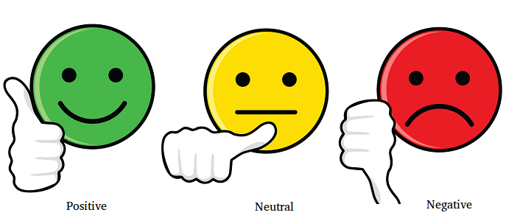

We all use different apps of play stores and app store and we give different opinions on different apps. There is a huge amount of reviews on every app. Now if the developer of an app wants to know about his app that whether the people have given positive reviews, negative reviews, and neutral on his app.

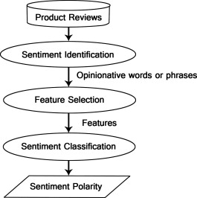

**Problem Statement**

As we know that if any developer wants to know about his application on the play store or app store then he needs to check all the comments/reviews that he received on his application. There is no application for this problem on the Play Store and App store for giving us sentiment about our application; we have to manually check all the reviews. Therefore, it is very difficult for a human to do it manually because sometimes applications having thousands or millions of Reviews so it is impossible for a human to do sentiment of that app.

**Problem Solution for Proposed System**

Now the question is how a developer will analyze his app when the reviews [data] is in huge amount like thousands of reviews on every app. Here a problem takes place that how a developer will know about his app.

Here comes sentiment analysis when no traditional way can solve this problem. The sentiment analysis uses machine learning and Natural language processing (NLP) to analyze such a vast majority of reviews or comments and provide better results for this task.

For example in customer feedback:

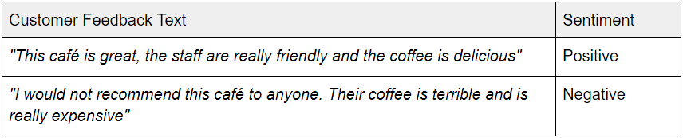

**Advantages/Benefits of Proposed System**

1. Upselling opportunities
2. Agent monitoring
3. Training chatbots
4. Identifying key emotional triggers
5. Handling multiple customers
6. Adaptive customer service
7. identify a dissatisfied customer
8. [customer satisfaction](https://www.whoson.com/customer-service/3-simple-steps-to-boost-live-chat-customer-satisfaction/)

**Scope**

Sentiment analysis provides an environment and platform for the developer to easily go through the reviews given by the user also sentimental analysis is being used by many organizations to get reviews about their products.

**Interdependencies**

Sentiment analysis depends on the reviews, reviews depend upon the users of the product, users depend upon the product, product depends upon the organization or developer and organization is independent.

**Software Process Methodology**

In this system, we will use Machine learning and Natural Language Processing (NLP) to classify sentiments on reviews of the app.

Firstly, we need a dataset to make our ML model and then train the data set on this model. We can get this dataset by the scraping technique. When our ML model will train then we will test its accuracy. If the accuracy is satisfying then we will use it further but if the accuracy is not satisfying then we will train it again. This process will repeat until we get high accuracy.

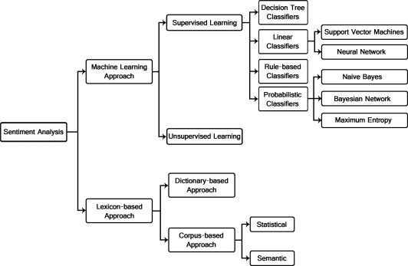

Now on the front end, the user will give input its app id and check for results. At the backend, we will scrap its app’s reviews from the play store or app store through google play store API. These scraped reviews will be tested on our model and then our model will show results according to the given data.

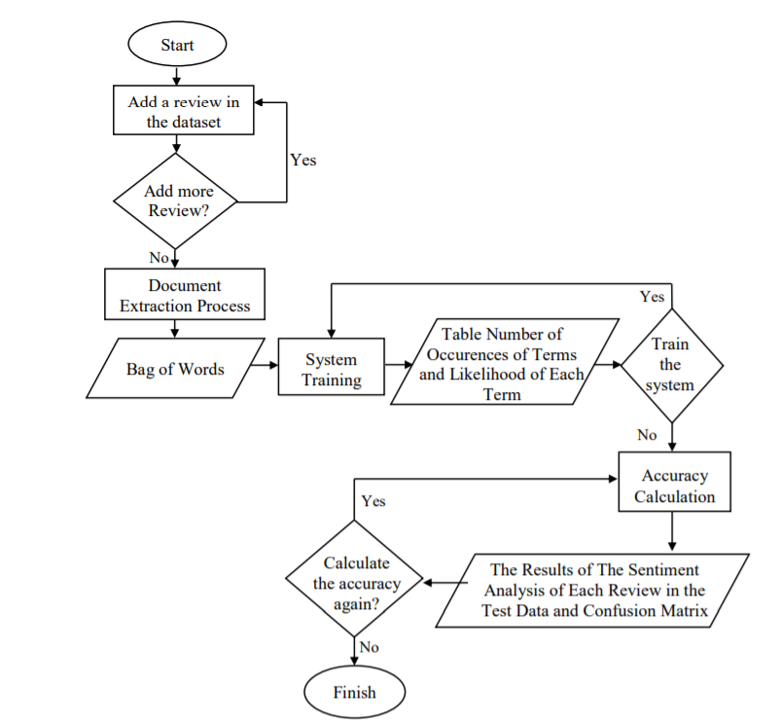

Fig: Flowchart of App review sentiment analysis system

**Tools and Technologies**

**SVM (Support Vector Machine)**

“Support Vector Machine” (SVM) is a supervised machine learning algorithm that can be used for either classification or regression challenges. However, it is mostly used in classification problems. In the SVM algorithm, we plot each data item as a point in n-dimensional space (where n is a number of features you have) with the value of each feature being the value of a particular coordinate. Then, we perform classification by finding the hyper-plane that differentiates the two classes very well (look at the below snapshot).

[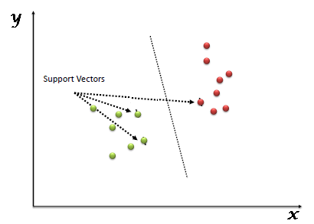](https://www.analyticsvidhya.com/wp-content/uploads/2015/10/SVM_1.png)

Support Vectors are simply the coordinates of individual observation. The SVM classifier is a frontier, which best segregates the two classes (hyper-plane/ line).

**Project Stakeholders and Roles**

* Customers / Clients

Our target audience will be the developers, companies, organizations who will use our product according to their requirements.

* Employees

The team who will make this software, which includes designers, coders, testers, etc.

* Investors

Definitely, in every project, we need some investments and support from the people who can help to make our software successful. Investors include both shareholders and debtholders. Shareholders invest capital in the business and expect to earn a certain rate of return on that invested capital. Investors are commonly concerned with the concept of shareholder value.

**Data Gathering Approach**

We made a dataset containing almost 30000 reviews with their review and sentiment. We will train our model with this dataset.

**Conclusion**

The age of getting meaningful insights from social media data has now arrived with the advance in technology. For a recommender system, sentiment analysis has been proven to be a valuable technique. A recommender system aims to predict the preference for an item of a target user. Mainstream recommender systems work on explicit data set. For example, collaborative filtering works on the rating matrix and content-based filtering works on the meta-data of the items. In many social networking services or e-commerce websites, users can provide text reviews, comments, or feedback on the items. These user-generated texts provide a rich source of user's sentiment opinions about numerous products and items. Potentially, for an item, such text can reveal both the related feature/aspects of the item and the users' sentiments on each feature

**References**

[1] “Sentiment Analysis: Beyond Polarity”, <https://www.cs.bham.ac.uk/~smithpm/publications/documents/rsmg3.pdf>

[2] “Sentiment Analysis Projects & Topics For Beginners [2021]”, <https://www.upgrad.com/blog/sentiment-analysis-projects-topics-for-beginners/>

______________________________________________________________________________